**Experiment No. - 1**

**Student Name: Vivek Kumar UID: 21BCS8129**

**Branch: BE-CSE(LEET) Section/Group:20BCS-ST-801/B**

**Semester: 6th Date of Performance: 14/02/2023**

**Subject Name: Competitive coding - II Subject Code: 20CSP-351**

1. **Aim/Overview of the practical:**

**Q1. Jump Game II**

https://leetcode.com/problems/jump-game-ii/

1. **Apparatus / Simulator Used:**
2. Windows 7 or above
3. Google Chrome
4. **Objective:**
   1. To understand the concept of Array and Jump Concept
   2. To implement the concept of Array Implementation.

**4. Code:**

class Solution {

public int jump(int[] nums) {

int answer = 0, n = nums.length;

int curEnd = 0, curFar = 0;

for (int i = 0; i < n - 1; ++i) {

curFar = Math.max(curFar, i + nums[i]);

if (i == curEnd) {

answer++;

curEnd = curFar;

}

}

return answer;

}

}

**5. Result/Output/Writing Summary:**

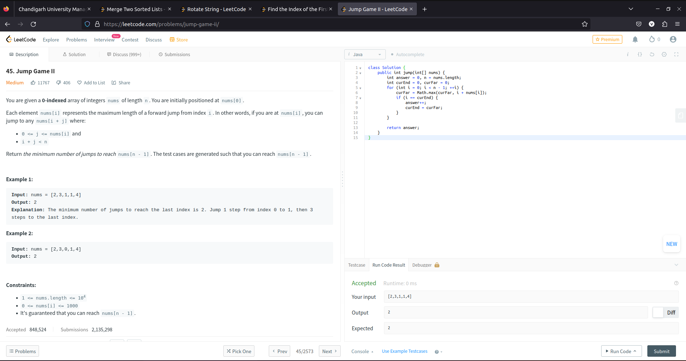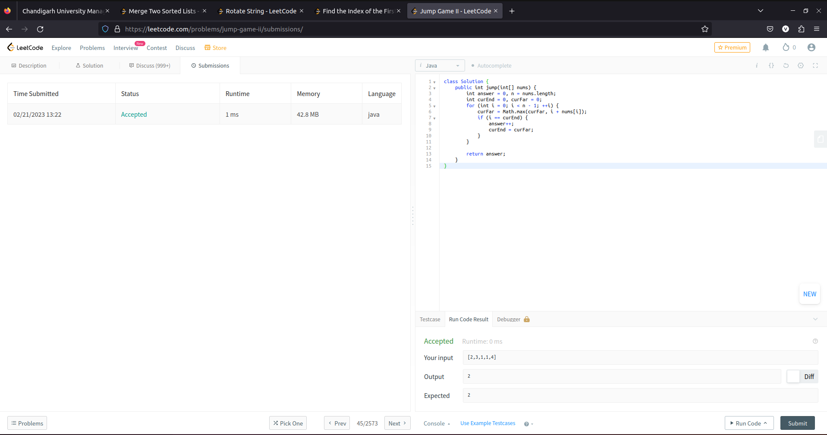

1. **Aim/Overview of the practical:**

**Q2. Merge Two Sorted List**

https://leetcode.com/problems/remove-duplicates-from-sorted-list-ii/

1. **Apparatus / Simulator Used:**
2. Windows 7 or above
3. Google Chrome
4. **Objective:**
   * To understand the concept of List and Node
   * To implement the concept of Remove duplicates from the list
5. **Code:**

class Solution {

public ListNode deleteDuplicates(ListNode head) {

ListNode sentinel = new ListNode(0, head);

ListNode pred = sentinel;

while (head != null) {

if (head.next != null && head.val == head.next.val) {

while (head.next != null && head.val == head.next.val) {

head = head.next;

}

pred.next = head.next;

} else {

pred = pred.next;

}

head = head.next;

}

return sentinel.next;

}

}

1. **Result/Output/Writing Summary:**

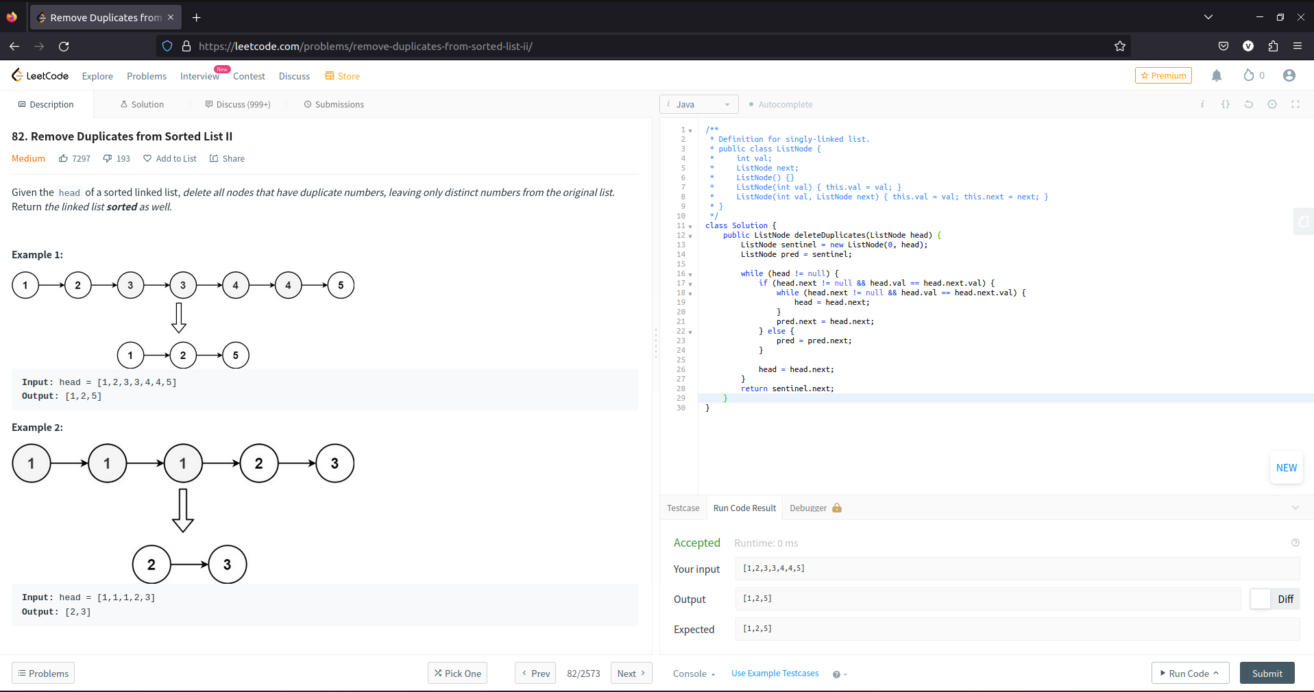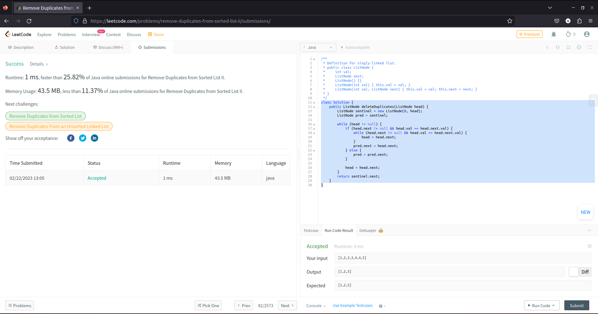

**Learning outcomes (What I have learnt):**

* + Learned the concept of LinkedList.
  + Learnt about Removing Duplicates from the List.

**Evaluation Grid (To be created per the faculty's SOP and Assessment guidelines):**

|  |  |  |  |
| --- | --- | --- | --- |
| Sr. No. | Parameters | Marks Obtained | Maximum Marks |
| 1. | Worksheet completion including writing learning objectives/Outcomes.  (To be submitted at the end of the day). |  |  |
| 2. | Post-Lab Quiz Result. |  |  |
| 3. | Student Engagement in  Simulation/Demonstration/Performance and Controls/Pre-Lab Questions. |  |  |
|  | Signature of Faculty (with Date): | Total Marks Obtained: |  |